Assignment 1: Indexed Arrays

Problem Statement
Create an indexed array named $months containing the names of all twelve months. Display each month using a for loop with the count function.

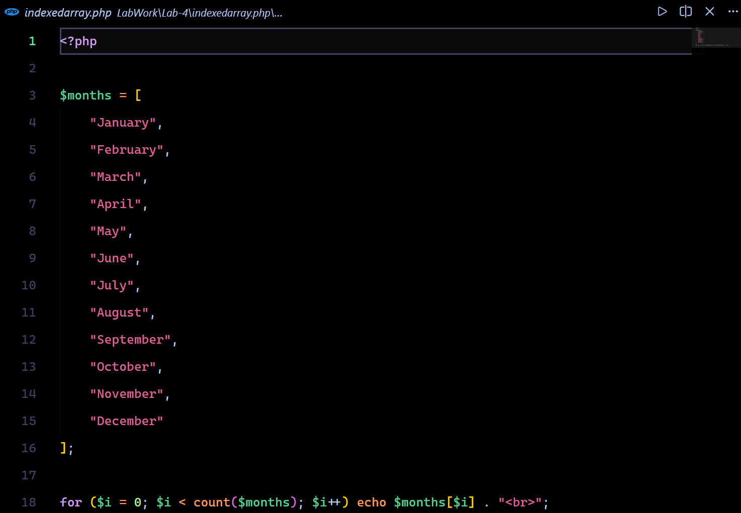
Source Code

Output

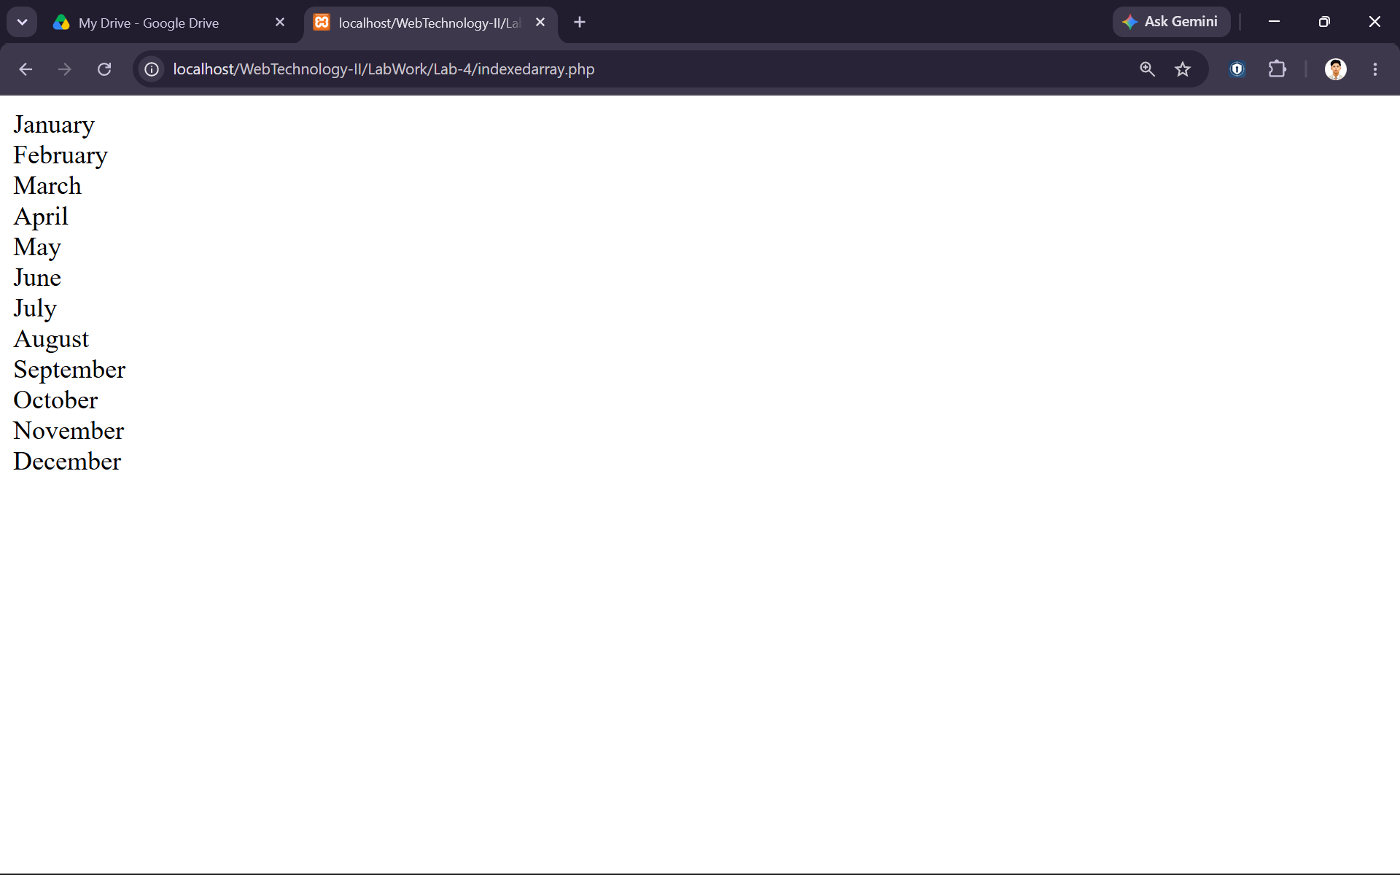

Assignment 2: Associative Arrays

Problem Statement
Create an associative array that maps each month to its number of days and display the result using a foreach loop.

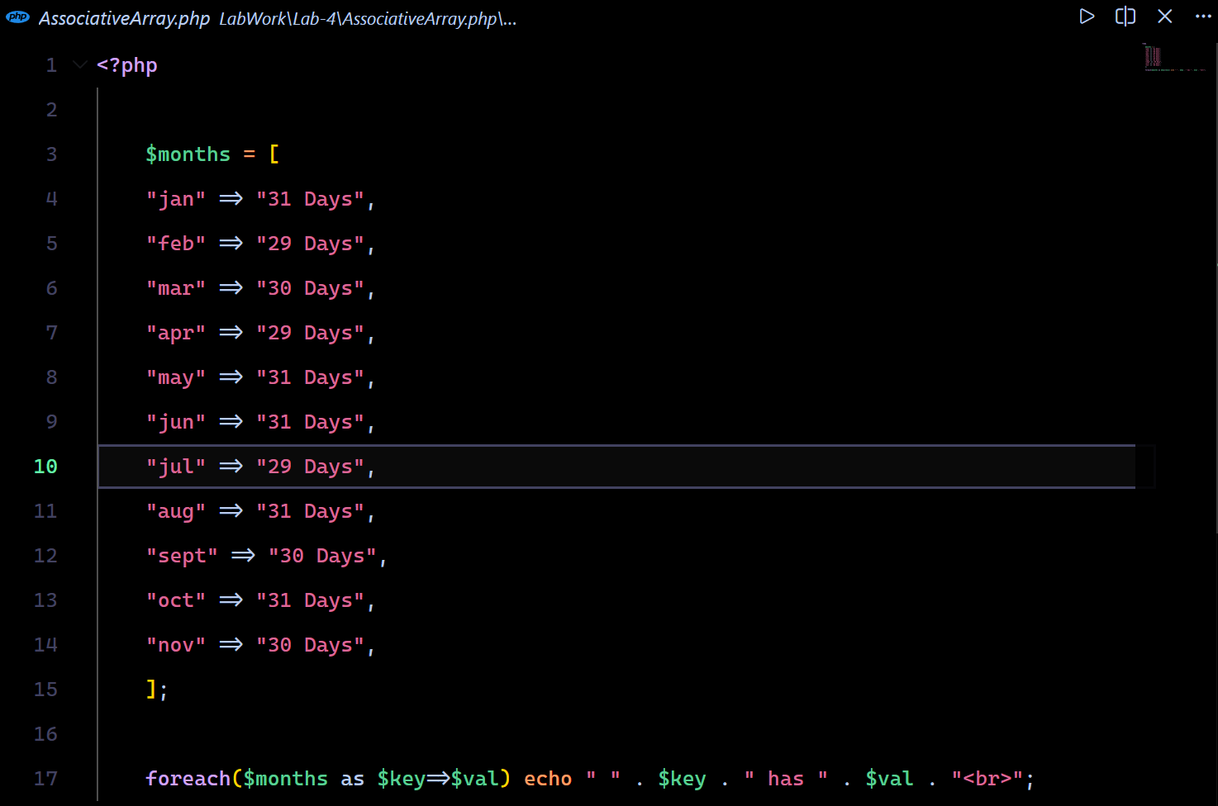
Source Code

Output
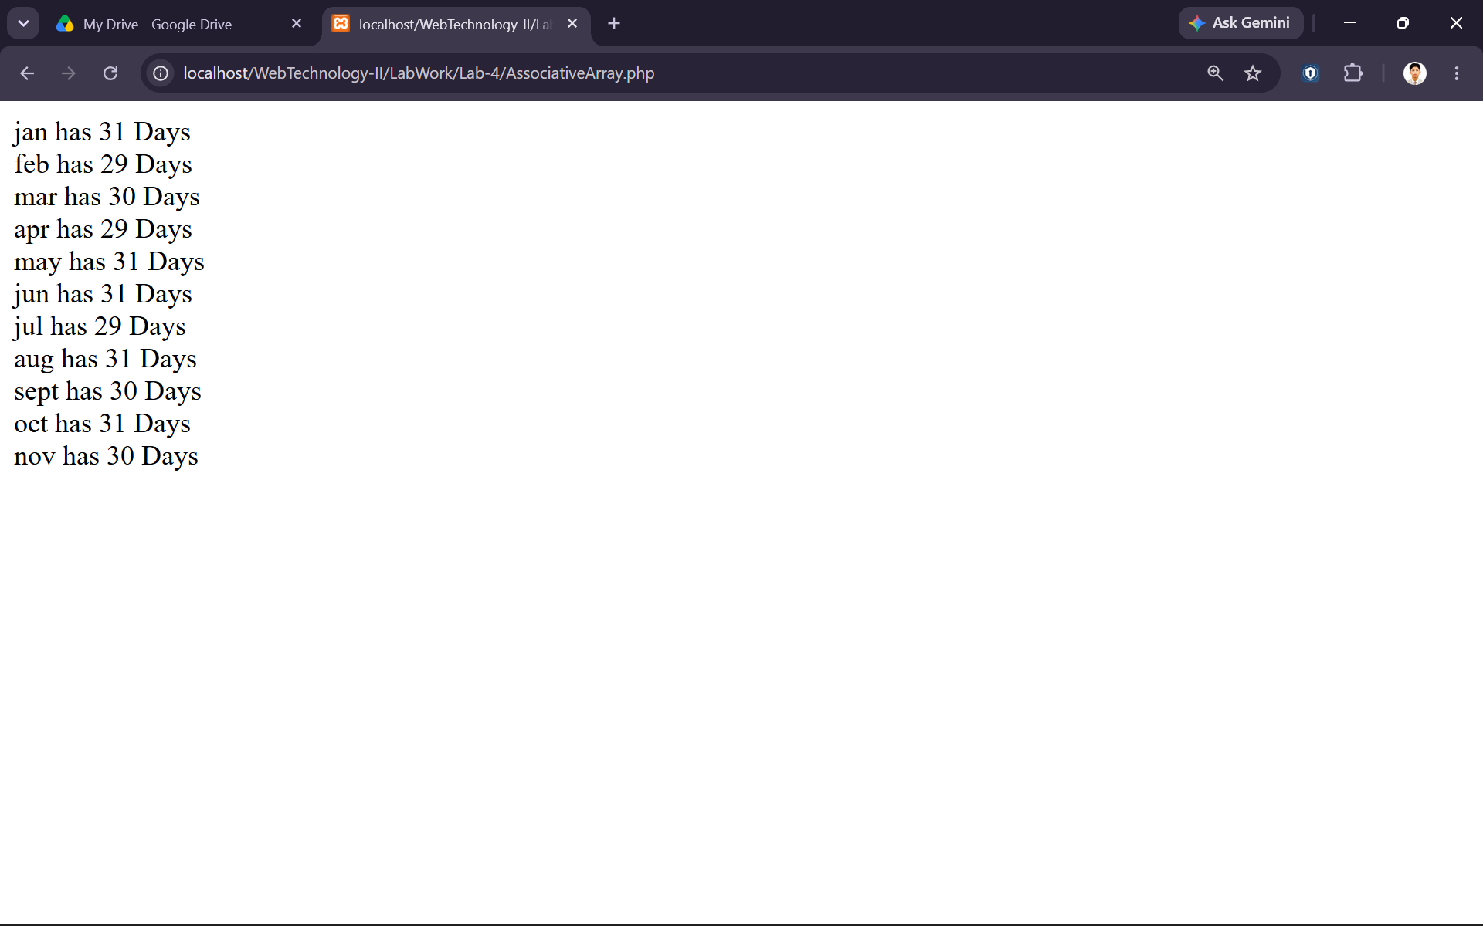

Assignment 3: Multidimensional Array

Problem Statement
Create a multidimensional array containing the Name, Age, and Gender of four individuals and display it in an HTML table.

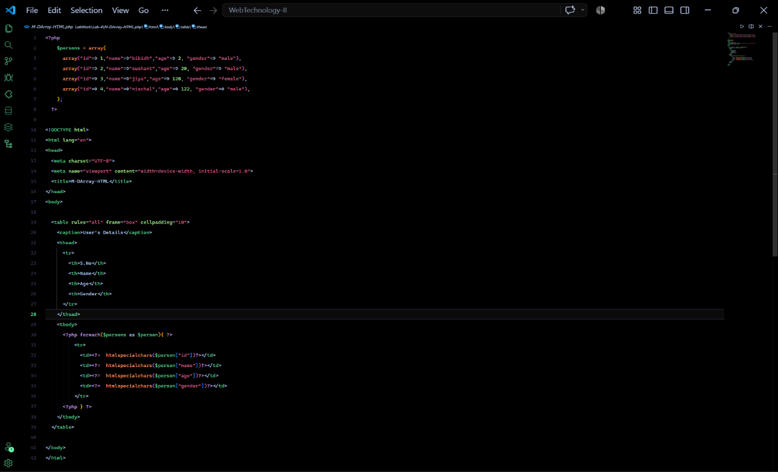
Source Code

Output

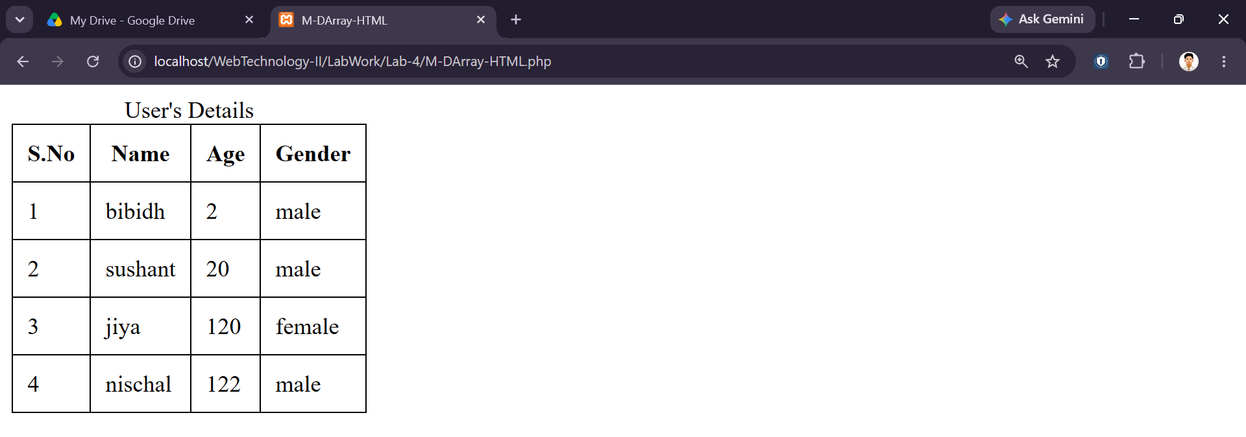

Assignment 4: Regular Expressions

Problem Statement
Validate a user's mobile number using regular expressions with preg_match().

Source Code
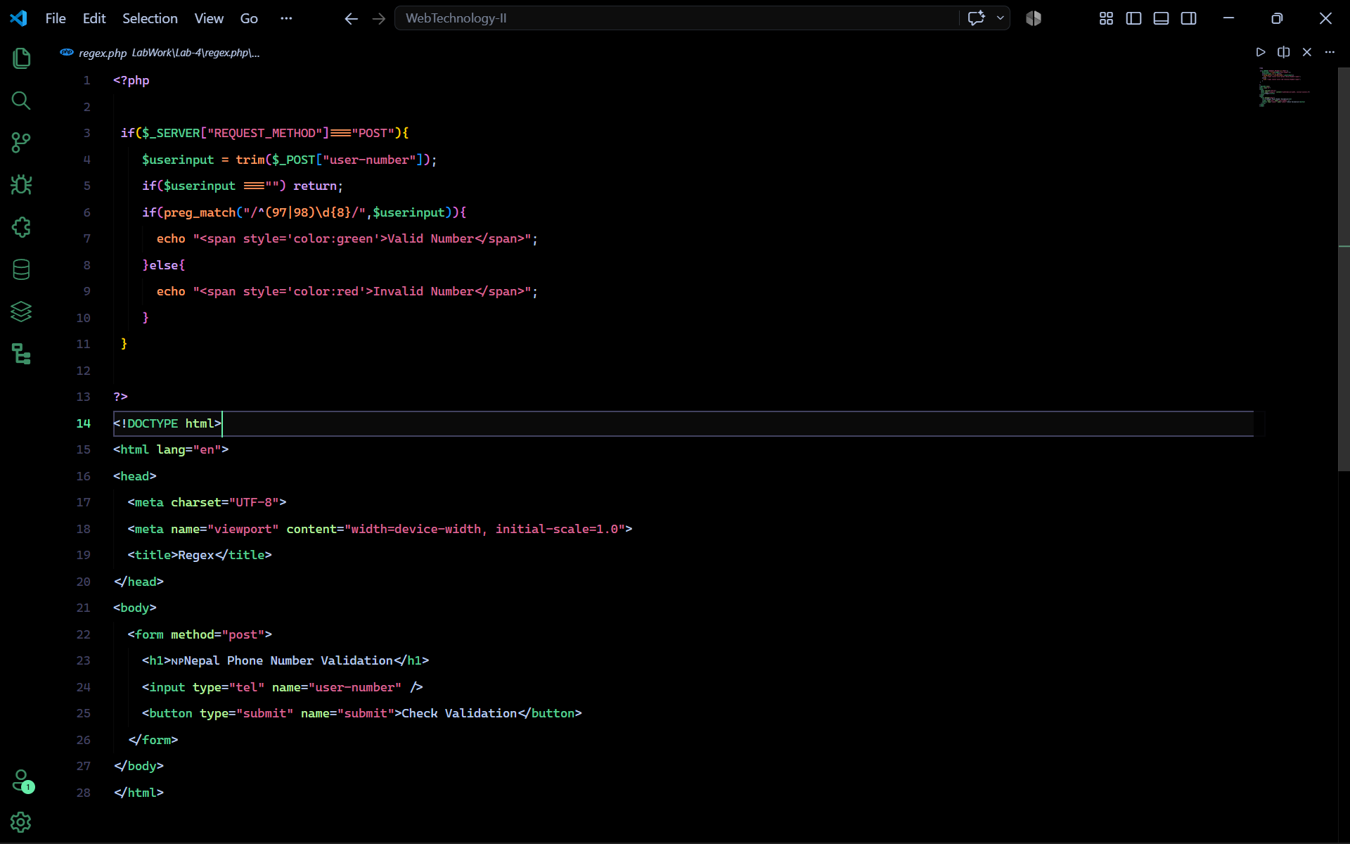
Output
